# CS 255 System Design Document - Cochrane

### UML Use Case Diagram

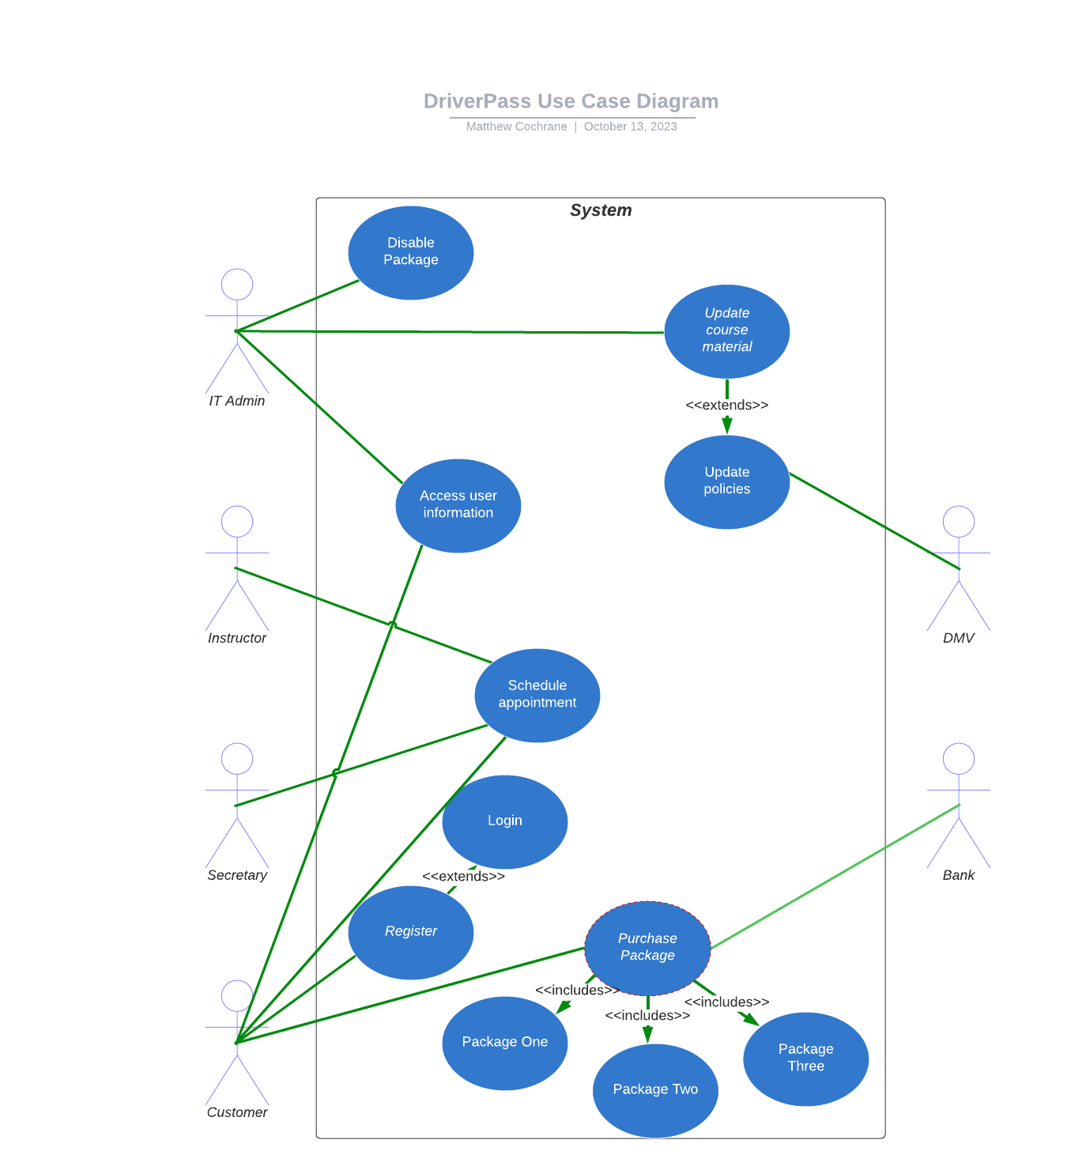

### UML Activity Diagrams

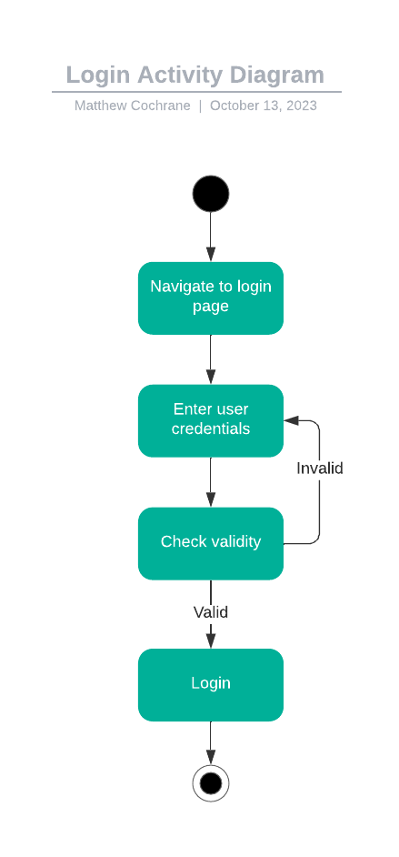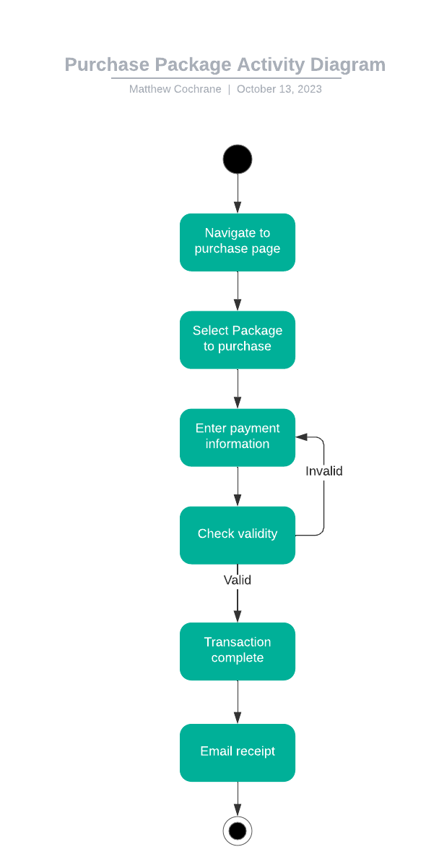

### UML Sequence Diagram

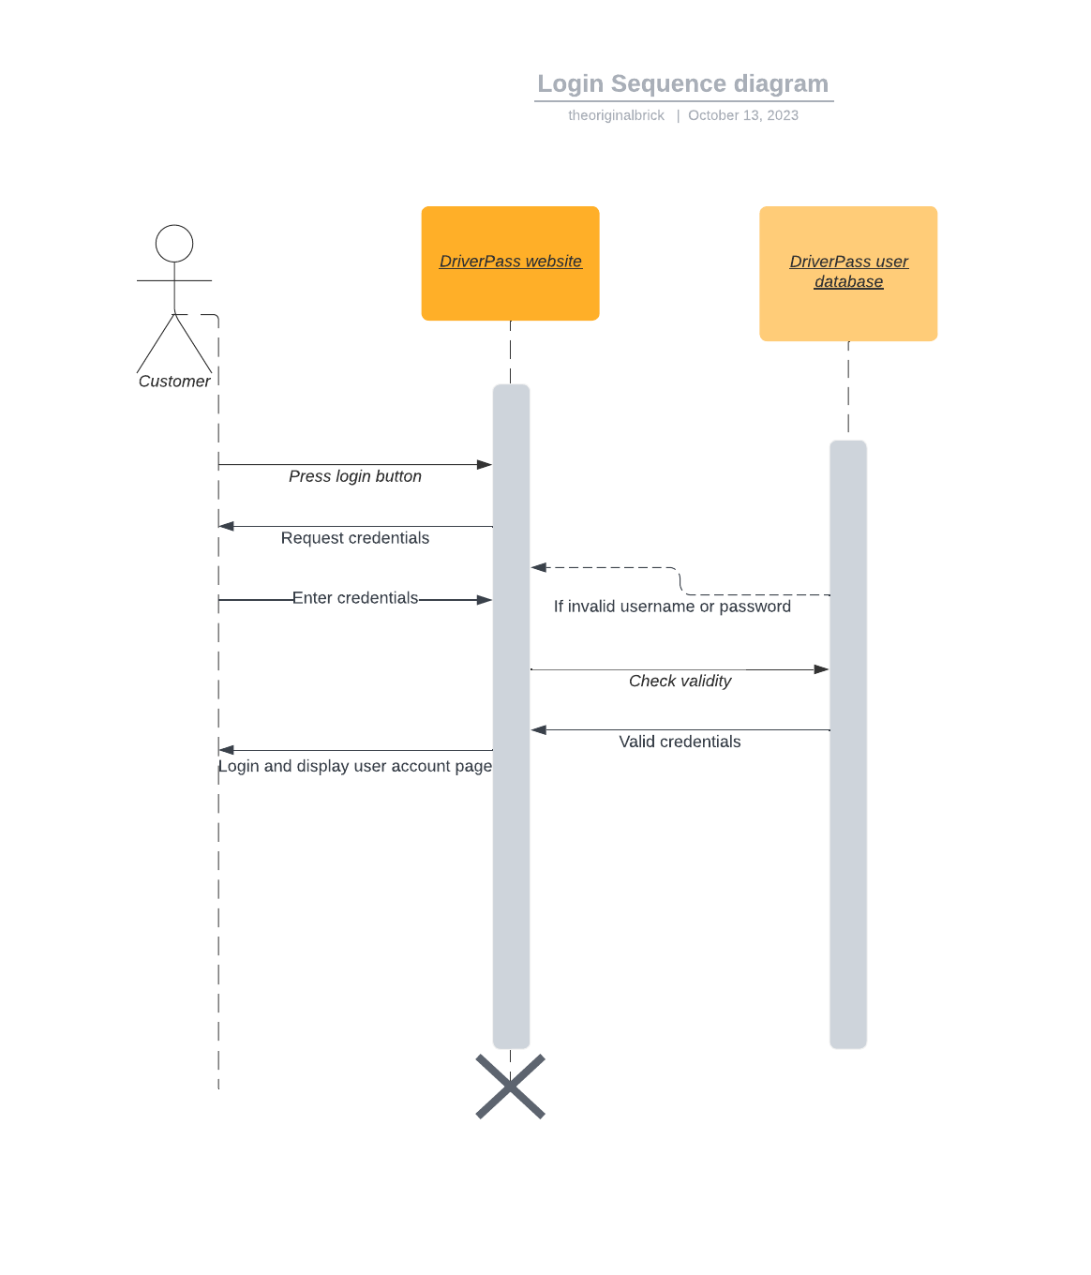

### UML Class Diagram

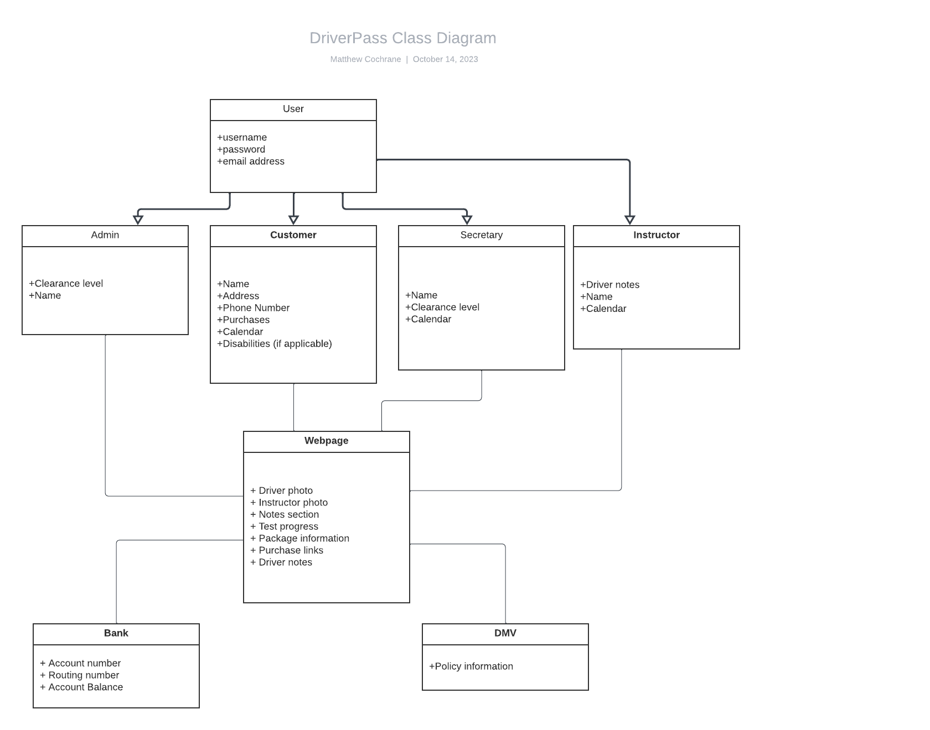

## Technical Requirements

Hardware:

* Web-capable device, such as a smartphone or PC
* Cloud server

Software:

* A web browser, preferably a well known one like Chrome or Safari to ensure compatibility

Tools:

* Algorithm for scanning DMV policy updates
* SHA-256 encryption for user information
* Secure connection with banking service
* Varying levels of access available depending on user

Infrastructure:

* Databases stored on cloud server
* Modular packages that can be added or removed
* System for allocating instructor
* Notification system for customers